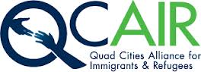

***Vision statement:*** “To build community among refugees, immigrants, and the receiving communities of the Quad Cities”

***What is QCAIR?***

QCAIR is a 501(c)(3) non-profit organization meeting unfilled needs of immigrants and refugees in the Quad Cities. On February 23rd, 2012, QCAIR was established from a series of public dialogues in Rock Island in 2010 and 2011. QCAIR collaborates with local and non-local service agencies to create, develop, and implement programs to meet these needs. Since streamlining our goals, QCAIR has won two awards: the Quality and Commitment Agency Award from the Council of Community Services of the Quad Cities and the 2014 Justice Image Award from the NAACP of Rock Island County.

QCAIR is undergoing its first strategic planning since it was first established. We are restructuring, reorganizing, and building capacity to give us a focus in order to ensure financial growth and sustainability.

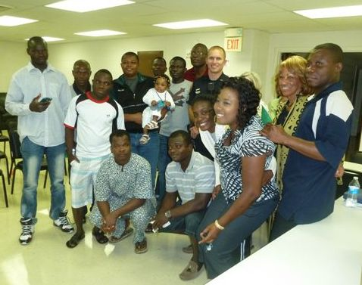

***What is the difference between an immigrant and a refugee?***

**Refugees** are sent to developed nations through the United Nations via various organizations around the world due to conflicts in their native countries. Most refugees come to the United States with limited to no English. They are from various cultural backgrounds and most have had traumatic experiences in their countries of origin. World Relief is one of the resettlement agencies for refugees. Refugees often arrive from Myanmar (Burma), Nepal, Vietnam, the Democratic Republic of Congo, Burundi, Rwanda, Pakistan, Bosnia, North and South Sudan, and Liberia.

**Immigrants** are individuals who plan entry into the United States. Immigrants often arrive in the United States from Nigeria, Senegal, Mexico, India, China, and Togo.

***QCAIR Success Story***

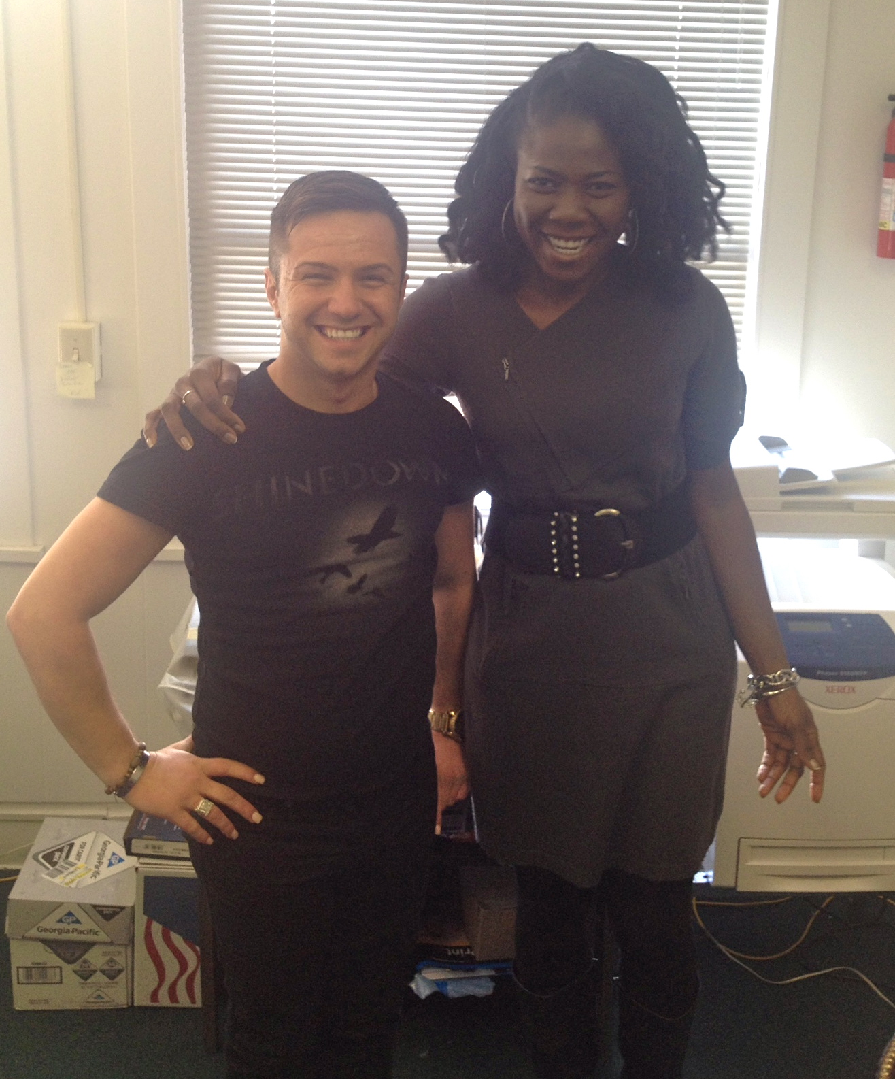Denis Arslanovic came to the United States in 1997 at the age of eight, as a refugee from Bosnia. He came with his mother, father, brother, and sister. Denis attended Wilson School in Moline. He moved to California with his mother at the age of 16. Denis was given 10 years “refugee status”, and after ten years, Denis was expected to go through the naturalization process of gaining citizenship. Denis came to the United States at such a young age, he was never educated about the process, neither was his family. In Denis’s heart he was an American citizen. At 18, Denis realized that he needed to get citizenship but didn’t realize the urgency or severity of the issue, so he put it off. When Denis was 20, he was finally confronted by a judge and was sent to the Eloy Detention Center for illegal immigrants in Arizona, where he stayed for nine months. Shortly after he was released, he moved back to the Quad Cities. Now Denis started working on the process of becoming a legal citizen, but all his efforts where to no avail; he was beginning to give up hope. Denis saw a flyer for the “New Americans Initiative” a forum hosted by QCAIR on December 3, 2013 to educate immigrants and refugees on the process of becoming an American citizen” Denis met I.K. Oriaikhi, Executive Director for QCAIR, for the first time at this forum. QCAIR had never been confronted with this type of case, so I.K. Oriaikhi, reached out to service agencies in Chicago that work on cases like Denis’s. In her search she met with Michael Gosch from “Interfaith for Detained immigrants” in February, 2014. Through QCAIR’s partnership with “Interfaith for Detained immigrants” we were not only able to extend Denis's court hearing from 6 months to a year, but we were also able to start his work authorization permit process. Denis obtaining a work authorization permit would show the U.S. Immigration Services (USCIS) that he is a productive member of the community/society. QCAIR sent a letter of support, along with letters of support from members of the community to USCIS. Finally, on March 2, 2015 Denis went to the USCIS office in Naperville for his biometrics, the first step in receiving his work authorization permit. Denis is now waiting for USCIS to adjudicate his application.

***Action Teams***

**Jobs and Employment:** This action team assists immigrants and refugees in integrating into the Quad Cities through searching and obtaining gainful employment. From April to August 2014, we found jobs for 18 immigrants and refugees in the Quad City area. This action team…

* Partners with local organizations to set up job workshops that teach immigrants and refugees how to create resumes, cover letters, and complete job searches online for immigrants and refugees
* Teaches immigrants and refugees about appropriate attire and etiquette for interviews and holds mock interviews
* Receives donations from the community for male business attire and partnering with Dress for Success for female business attire. We will be having an outdoor sale in summer 2015.
* This action team is taking a new path by partnering with local employers in the community to get immigrants and refugees employed. This action team is acting as a hiring agency to get more immigrants and refugees with little to no English and formal education but have untapped skills from their countries of birth.

**Positive Interaction with Police (PIP):** This action team helps facilitate healthier interactions between immigrants and refugees and local law enforcement agencies through:

* A four-week cultural diversity presentation workshop attended by about 80 Rock Island officers.
* Various ethnic forums throughout the year in order to build trust and cooperation among police, immigrants, and refugees. There are one or two uniformed officers present at these forums.
* Creation of language resource cards (LRCs) for non-crisis situations for immigrants and refugees to provide to police officers when they are pulled over. This card will include their name, country of origin, languages they speak and phone number of an interpreter appointed by that immigrant or refugee. Interpreter has to be 18years or over, to ensure kids are not being pulled out of school.

**What has the PIP done?**

“The PIP Action Team had the privilege, once again, to meet with and provide information to officers of the Rock Island Police Department to help increase positive interactions among immigrants, refugees, and police. We started this four-week training sessions last year January-2014. You could otherwise call the meetings training sessions; however, they were more like good old sit-down kitchen conversations with a panel of experts ready to field questions. Note-taking and positive dialogue back and forth proved very fruitful according to survey results from all sessions. A collaborative effort provided a clear and concise presentation which included Amy Rowell, World Relief, Nana Ouro-Agoro, New Americans Initiative, faith-based, Pastor Brian McMaster (Broadway Presbyterian), Ikponwonsa Oriaikhi, QCAIR Executive Director and Xochi Pannell, Marriage & Family Therapist, Hispanic/Latino advocate. This panel of experts outlined the processes Immigrants and Refugees follow upon arrival to the US. Discussions surrounding some “root causes” (language barriers), “circumstances” (cultural differences) and/or behaviors and interactions (fear of authority) with these entities helped to convey the need for Police education in policing safety. On the other-hand, Community Forums were hosted and presented for Immigrants and Refugees to have conversations about local laws and police practices with “actual” police officers in a non-threatening environment- The common thread being language barriers and finding a way to bridge that gap. Leaders of groups acted as spokespersons or interpreters were provided for translation by the PIP.”

“ Law Enforcement cannot function adequately without the support and cooperation of the population that it serves and that population includes the immigrant and refugee community.  Our partnership with QCAIR helps us gain a better understanding and in turn provide better service for our growing immigrant & refugee population.”

Jeff VenHuizen

*Rock Island Police Chief*

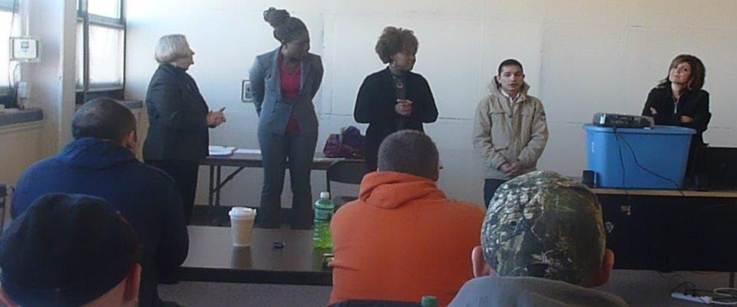

**Health:** The health team advocates for and educates immigrants and refugees, as well as health care providers to ensure effective communication mechanisms. Our team educates the target population about health and well-being and how to achieve good medical care through:

* The creation of two, one-page leaflets (translating into the 10 major languages spoken in the QC-Area) describing the medicinal benefits of over-the-counter medications, such as Tylenol, a guide about symptoms of certain illness and what to do when these symptoms arise in order to reduce emergency room visits.
* We have recently begun educating immigrants and refugees about the benefits of alternative medicine, as research has shown that most immigrants and refugees prefer alternative forms of medicine over mainstream medicine.

**Education and Learning:** This action team came up with a project scheduled to begin this year but due to the restructuring of QCAIR, our first strategic planning and funding it is now scheduled to begin as QCAIR grows and builds financial sustainability. This is a mid to long term goal and we are looking to fill in the chair position for this action team. This action team’s goal is to partner with local churches, schools, and colleges, health agencies, and local service agencies that deal with child, youth, and family development to create an afterschool program directed at immigrant/refugee children and their families.

**Housing:** The focus of this action team is to help immigrants and refugees understand the process of finding and maintaining a place of residence through the following programs:

* Production of DVD’S translated into 10 main languages spoken in the QC-Area. These DVD’s explain details of rental properties.
* Helping immigrants and refugees learn the necessary steps in buying a home, including details about mortgages, credit, property taxes, interest rates, and types of homes.

***Thanks to our funders/supporters:***

***Board of Directors:***

**Officers:**

President: Ed Hanna

Vice President: Jean Baptiste Twizerumukiza

Secretary: Desiree Echavez Alfon

Treasurer: Vacant

**Action Team Chair Members:**

Development: Grant Curtis

Education: Vacant

Health: Tammy Reed

Housing Advocacy: Rick Schloemer

Jobs and Employment: Kym Mans

Positive Interaction with Police: Marsha Jones

**At-Large Directors:**

Dale Haake

Zena Feliki

**Riverboat Development Authority**

(www.riverboatauhority.com)

**Catholic Diocese of Peoria**

([www.cdop.org](http://www.cdop.org))

**Quad-City Times**

(www.qctimes.org)

**Rock Island Community Foundation**

(www.ricf.org)

**Community Foundation of the Great River Bend**

(www.cfgrb.org)

**The Hubbell- Waterman Foundation**

([www.hubbellwaterman.org](http://www.hubbellwaterman.org))

**New American Initiatives**

**The Philippine Dance Troup of the Quad Cities**

**Broadway Presbyterian Church:** for partnering with us to create an afterschool program for immigrant and refugee children and for providing space for our "Work Ready Men's Wear Event" in September 2014 ([www.broadwayqc.org](http://www.broadwayqc.org))

**Augustana College:** for providing interns to QCAIR ([www.augustana.edu](http://www.augustana.edu))

**Retired and Senior Volunteer Program of Eastern Iowa and Western Illinois:** for their unlimited support

([www.nationalservice.gov](http://www.nationalservice.gov))

**Doris and Victor Day Foundation**

([www.dayfoundation.org](http://www.dayfoundation.org))

**Martin Luther King, Jr. Community Center**

([www.rigov.org](http://www.rigov.org))

***If you would like to support our mission with a financial gift, please send your donations to:***

Quad City Alliance for Immigrants and Refugees

1800 3rd Avenue, Suite 501

Rock Island, IL 61201

Jack Knepp

Pam Hauman

Gail Brooks

Amy Rowell

Glenda Nicke

Morten Wabyaombe

Sue Swisher

Francois Niyungeko

Brian McMaster

***Special thanks to former QCAIR board members who still support our mission:***